

# **SoPro**

# QA Engineer Recruitment Test

V1.0 Aug 2020

# Overview

The enclosed test is designed to be indicative of the types of tasks you would be expected to undertake day to day in the role within SoPro. You are free to complete the test in any way that feel is suitable, and free to consult any online sources for assistance – just as you would be able to in the job itself.

Please review the description and tasks below. If you have any questions regarding the test or how to complete, please contact [rob@sopro.io](mailto:rob@sopro.io).

# Description

Email verifier is a tool that enable users to validate email addresses before using them. Users can validate one email at a time using the Classic email verifier or they can switch to bulk email verifier and validate up to 10,000 emails at once.

* Verified emails are scored against a "SoPro Safe" criteria matrix and can have the following results:
  + OK, advice: Safe to send
  + Unverifiable, advice: Risky to send (Unable to create this scenario)
  + Bad, advice: Do not send
* The email verify feature will charge 1 satoshi credit for every email.
* If the email domain format is not valid satoshi credits will not be charged.

# Instruction

Please create a toolset account here - https://toolset.sopro.io/register and get 100 satoshi credits you can use for completing this test. If additional satoshi credits are needed, please contact us and provide the email address used to create the account and we’ll assign you additional credits.

Also, please find here the links to the Email Verifier tool:

• Classic email verifier - https://toolset.sopro.io/email-verifier

• Bulk email verifier - https://toolset.sopro.io/email-verifier/bulk

# Tasks

Once you have created Toolset account and reviewed the Email Verifier tool please proceed executing the following tasks.

Manual testing

1. Prepare the optimal (effective and efficient) set of test cases required to test each outcome of the tool.

Automation testing

1. Complete test automation setup (Selenium, Puppeteer or another stack you prefer with a reason for choosing them) required to start test automation project.

**Answer:**

* 1. **Test Automation Tool – Robot Framework (Python Built-in Library) and Selenium Library. Eclipse Juno and Robot IDE as editor.**
  2. **Open source, powerful language and continuous support.**
  3. **Large number of libraries provided (**[**https://robotframework.org/#libraries**](https://robotframework.org/#libraries)**)**

1. Setup an automated test for Email Verifier tool, both classic and bulk version.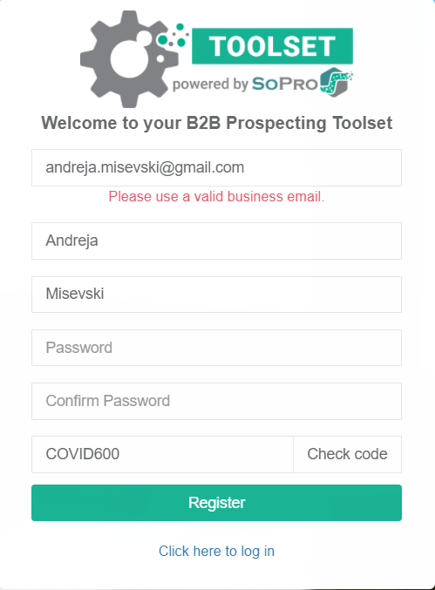

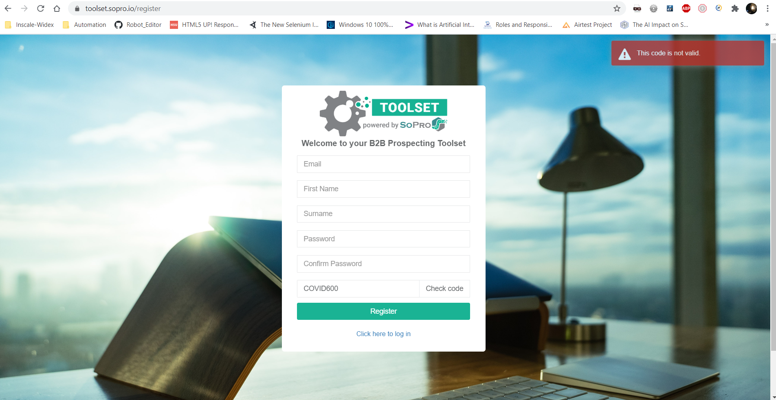

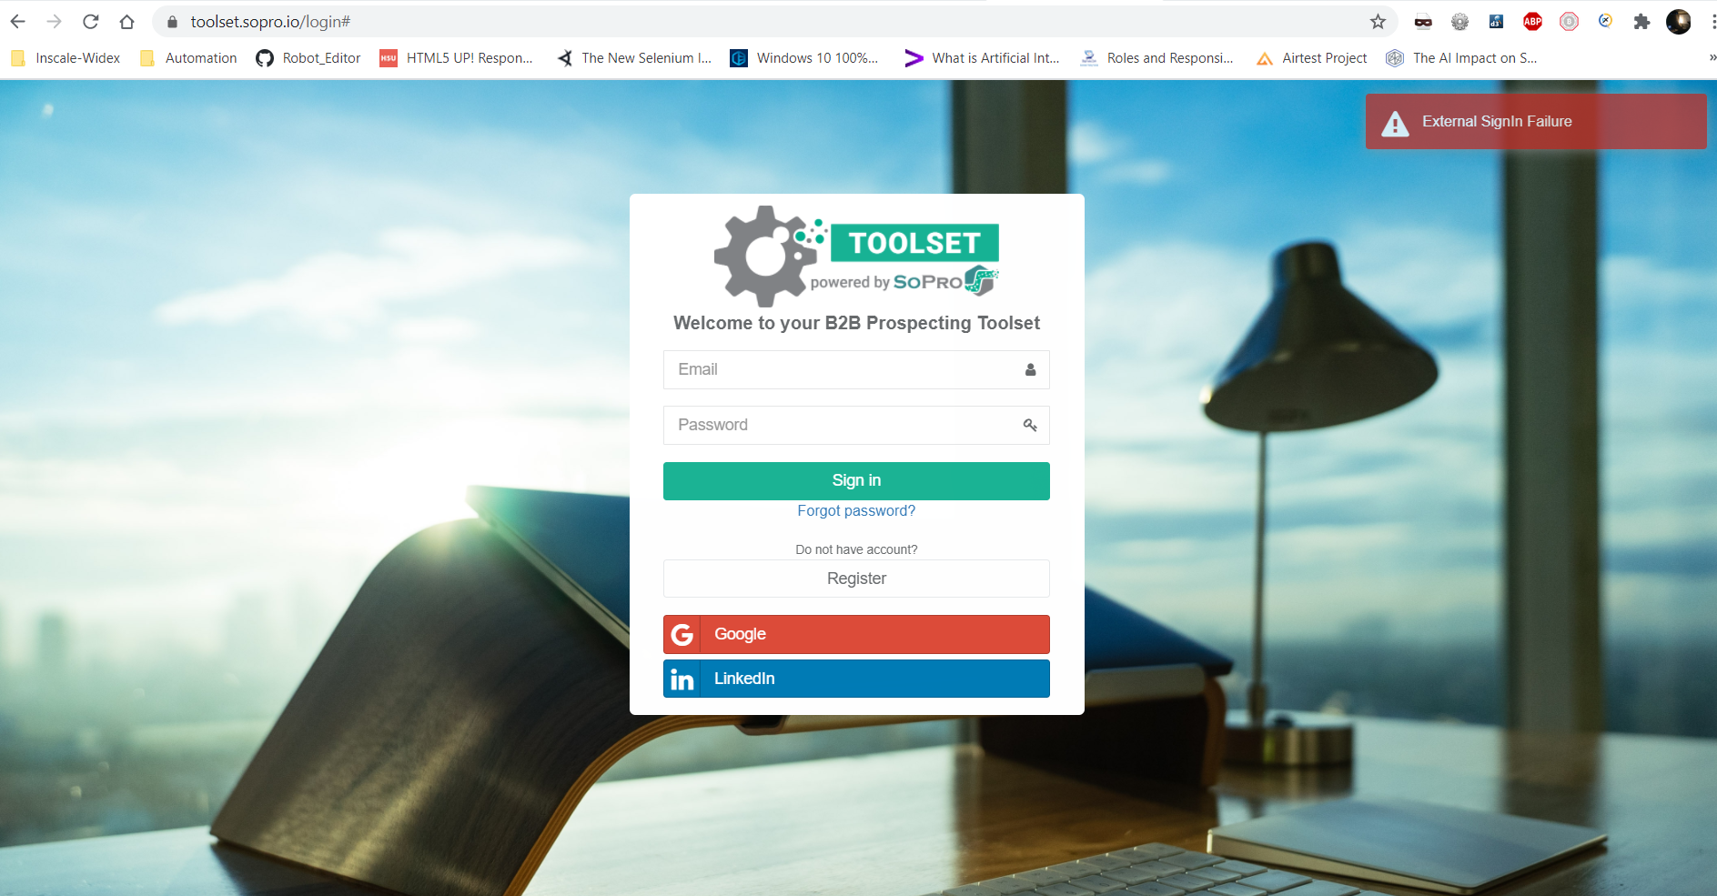

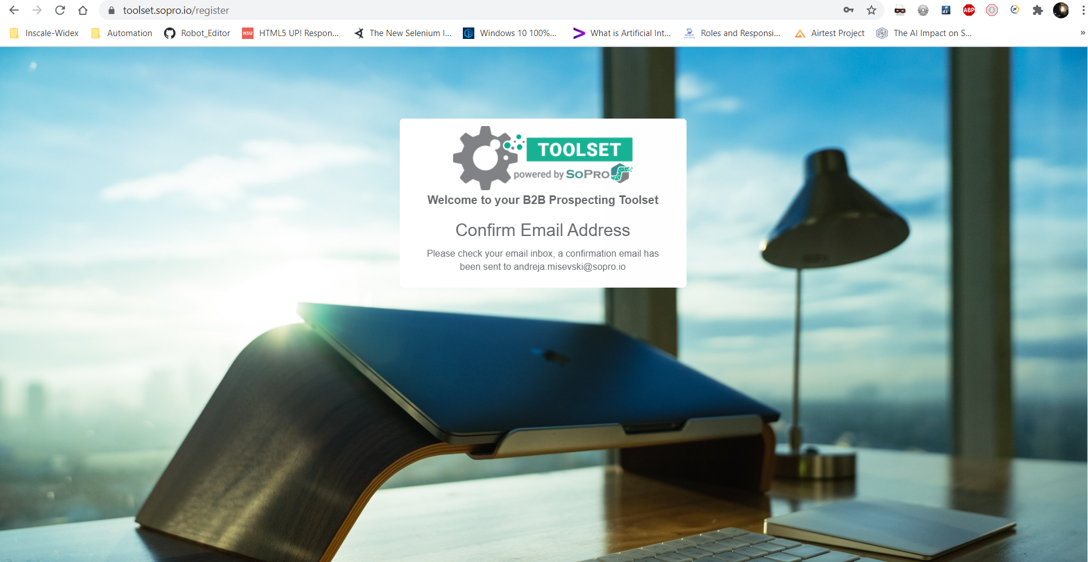

On Refresh this happened:

